## Dashboard

Available as an interactive dashboard on Tableau Public via this link:

<https://public.tableau.com/views/Book1_17330550559040/Dashboard1?:language=en-US&publish=yes&:sid=&:redirect=auth&:display_count=n&:origin=viz_share_link>

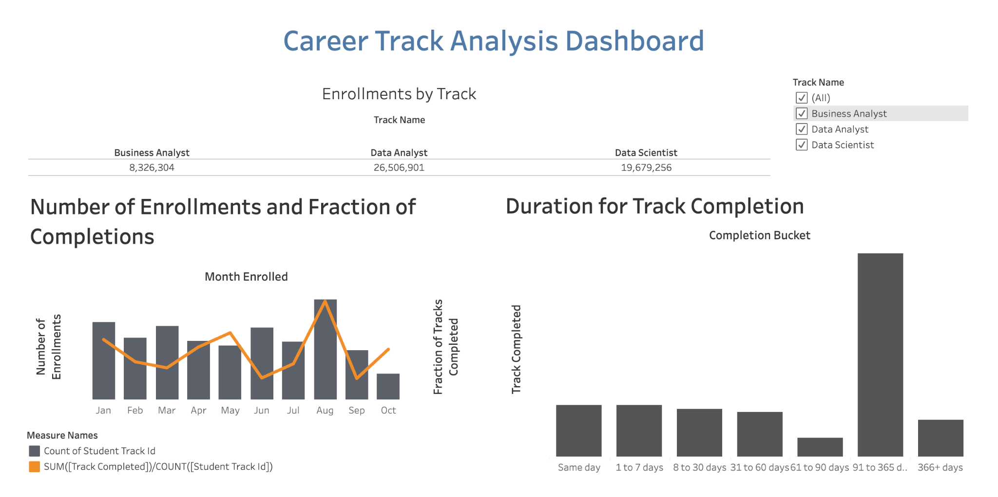

## Insights from Career Track Analysis Project

1. What is the number of enrolled students monthly? Which is the month with the most enrollments? Speculate about the reason for the increased numbers.

Jan - 1,284

Feb - 1,021

Mar - 1,261

April - 978

May - 898

June - 1,192

July - 958

Aug - 1,653

Sept - 815

Oct - 426

Month w most enrollments: AUGUST (1,653)

Reason for increased enrollments: official enrollment month?

1. Which career track do students enroll most in?

Data Analyst track with 26,506,901 enrollments

1. What is the career track completion rate? Can you say if it’s increasing, decreasing, or staying constant with time?

The career track completion rate is fluctuating. It decreases significantly from january to march followed by an increase from march to may then a decrease again. It follows a decrease-increase pattern after almost every 3 months. This might be due to seasonal trends or other external factors.

1. How long does it typically take students to complete a career track? What type of subscription is most suitable for students who aim to complete a career track: monthly, quarterly, or annual?

Most or majority of the students fall under the bracket of 91 to 365 days to complete a career track. Therefore, the most suitable type of subscription for students would be annually to offer students flexibility and time allowance to complete a course within a year. Some students would be able to complete it at a much faster pace so it’s also possible to include a special subscription which is quarterly.

1. What advice and suggestions for improvement would you give the 365 team to boost engagement, increase the track completion rate, and motivate students to learn more consistently?

* Create virtual communities and forums wherein students can communicate and interact with each other.
* Produce interactive contents that will interest students to study.
* Provide a healthy leaderboard that shows student progress without pressuring them.